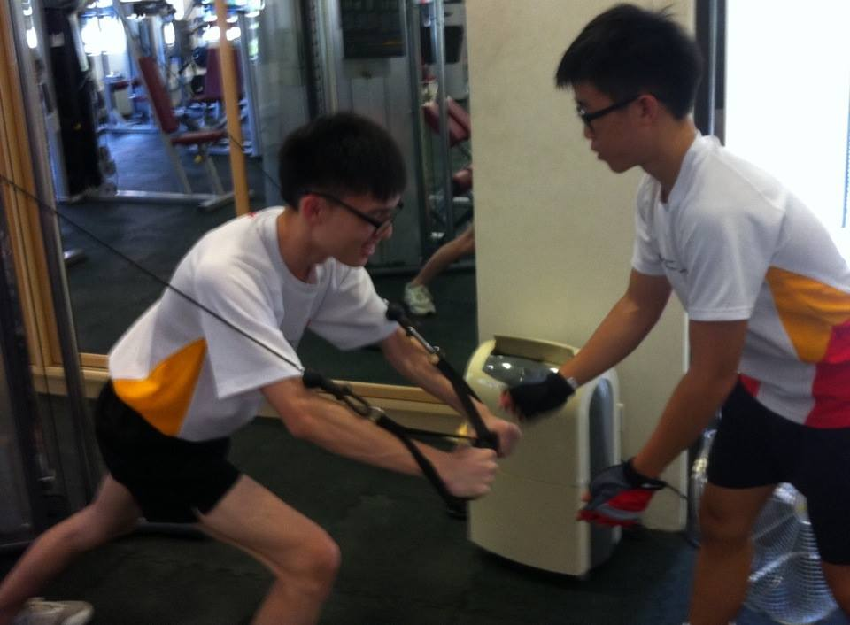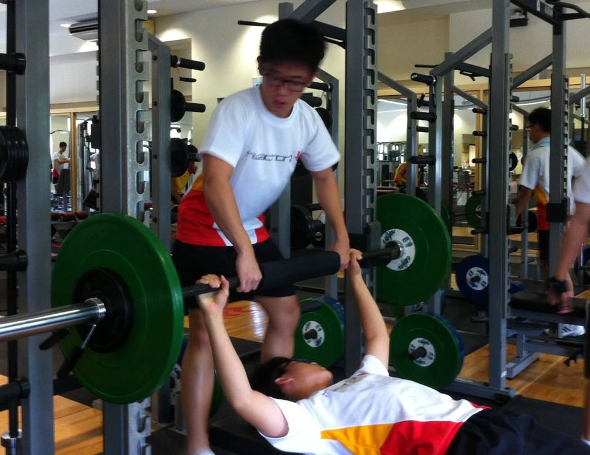 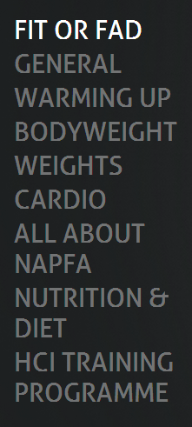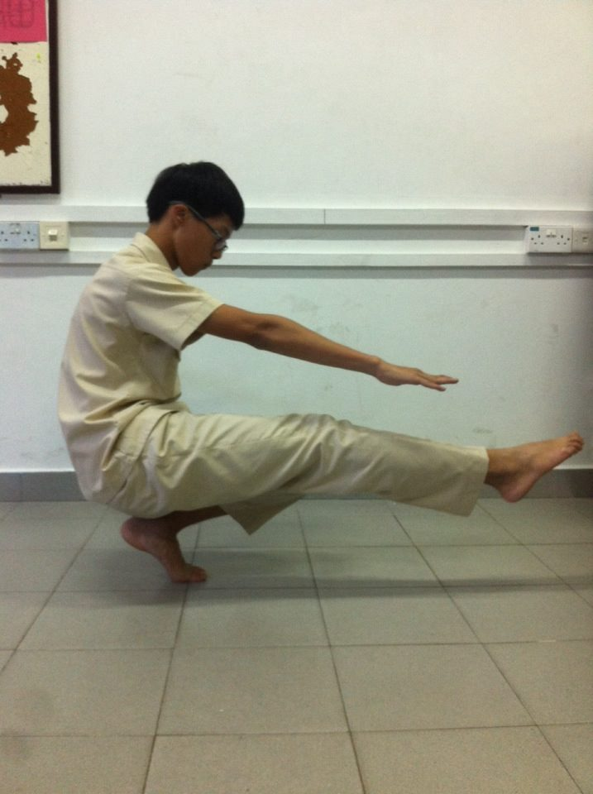

***Website*** includes information from fitness tips to napfa training exercises and also nutrition information

Our resource has everything you need!

Visit our website: http://fitorfad.weebly.com/

Having the desire to

keep fit but not

sure what to do?

Look no further!

Project Fit or Fad

Want to find out more?

Website Content Page

We are a group of students from Hwa Chong Institution who have realized how HCI students and the general teenage population do want to keep fit but do not know how to through surveys

# Why is this important?

* Being healthy would eliminate a lot of health risks later on in life
* Keeping fit would help boost CCA performance
* Prevent you from entering army 3 months early by boosting your napfa grades

Our ***Guided Training Sessions*** range from weights training to Bodyweight Training and cardiovascular workouts, teaching proper form and techniques

What’s stopping you? Go take a look at

[**http://fitorfad.weebly.com**](http://fitorfad.weebly.com)

right now and sign up for the guided training session!

Project done by:

Eugene Kam, Duan Chengwu,

Hope Leong and Marcus Ho

Introduction